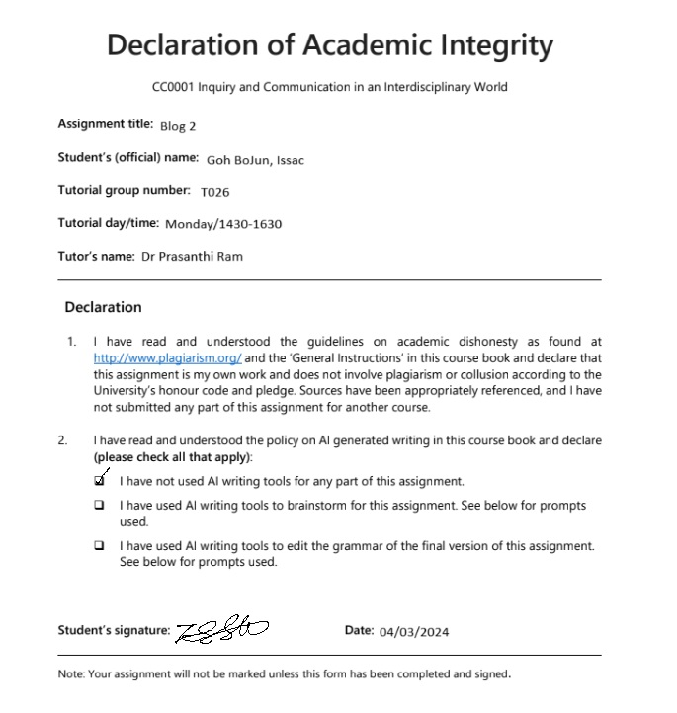

| Research Question (RQ) | Why do many Singaporeans continue to work during leisure time? | |
| --- | --- | --- |
| Source’s citation (APA)  Last name/s, First name initial. (DATE). Article title. *Journal/newspaper/website.* Pages/URL | Source 1:  Wee, Y. W. (2016). “Work-in-Life” : reconsidering work-life balance in Singapore. | Source 2:  Lim, Zhixun., Lim, L. Fei., & Tan, S. X. Xian. (2006). Recommendations on work-life balance in Singapore. |
| **Summary of Source (200 words each)**   * Introduce your source – author, year, title, subject and context. * Sum up the source’s argument **in your own words** – if it is a long paper, summarize only the claims that are useful and relevant. * Explain the reasoning supporting the argument’s claims, and if necessary, evidence. * Integrate ONE essential quotation (**should be a short phrase or short sentence**) into your own writing and cite the source: (Lee, 2010). | **Summary of Source (200 words each)**  In a research titled “Work-in-Life…” by Wee Ying Wei, she suggests that organization control through digital communication tools and normative control results in Singaporeans to work outside of their standard working hours.  She argues that organization control involves methods used by companies to ensure that workers are aligned with the goals of the company,traditionally through extrinsic rewards. However, companies have evolved to adopt normative control instead, enforcing behavioral norms through social expectations and cultural values present in the company.  Firstly, the transition into the digital age resulted in some company processes to be done digitally. This shift in paradigm has prompted some companies to provide technological tools to their workers to utilize outside of working hours, sometimes enabling workers to work remotely. This results in workers obtaining work-related documents during their down time through digital devices. Such a situation “creates a virtual office”, obscuring the distinction between work and leisure time, enabling employers to capitalize on employee’s personal time to continue working.  Furthermore, the presence of underlying social norms in the workspace imposes normative control on workers’ personal life by their company. Fulfilling work offered after hours often instills a sense of responsibility in workers, becoming a part of normative control within a company. By providing such opportunities, companies establish an expectation for employees to prioritize work even during personal time, fostering a culture where this behavior is normalized and expected. | **Summary of Source (200 words each)**  In a research titled “Recommendations on work-life…” by Lim Zhixun, Lim Lu Fei and Tan Stephanie Xiu Xian. They assert that the presence of such a working phenomenon is due to cultural and environmental influences.  Firstly, the cultural influence may have originated from the predominant Asian culture present in Singapore which can result in the culmination of a poor work-life culture. In Singapore actions are “influenced more strongly by Confucian dynamism”. This has spillover-effects to work-related attitudes and behaviors. They suggest that Confucian beliefs of virtue which place tenacity and adherence to pecking order are prioritized in the working space in Singapore. While Confucian values were meant to be in a positive way, individuals may adopt them in a neutral manner, yet the excessive adherence to these values can still lead to challenges in maintaining a healthy work-life balance.  Furthermore, the Singapore environment encourages workers to work beyond what is necessary. Being brought up in a capitalistic world, people are influenced to pursue materialistic wealth, with words even being invented to better encapsulate such an attitude such as “kiasu”. With high expense ratios compared to other countries, this can result in a never-ending pursuit for materialistic wealth that gets increasingly more expensive which pushes its citizens to work even harder to obtain it. |
| **Evaluation of Source (150 words each)**   * **Frame the source** for your reader. What angle or perspective does your source present? * What is **your main takeaway**? Identify the claims or concepts that address the RQ. Explain how these claims / concepts are related to the RQ. * Does the source have a **limitation or gap** in terms of **context** of publication, **scope** of argument or research, or **logic** (focus on just 1)? How does it remain applicable or useful in answering the RQ? * **Linking to your RQ:** Write a sentence that shows you moving beyond the source (extending or revising its claims/concepts) to offer a more convincing response to the RQ. (*This is important for the final op-ed, but is optional in Blog 2*). | **Evaluation of Source**  This article underscores the misuse of digital devices both by companies and employees which aligns with my observation of adults utilizing their laptops for work during their leisure time, showcasing the irony of flexible work arrangements.  However, this article evaluation is limited in terms of its scope of its argument by placing its main focus on organizational control through the use of digital devices and normative controls. This results in misrepresentation of other companies that adopt organizational control tools beyond communication technologies such as task tracking tools and sharedpoints. These tools allow employers to micromanage and know the activities of its employees at all times without the communicative features.Such tools also provide a form of control over the employee’s behavior by coaxing them to be more productive.  However, this article remains useful as it can be seen from the observation that communication technology is the main means to remain connected to work during their leisure time. Employees are also responsible for the effectiveness of normative control policies, by having too strong sense of responsibility, they conform to the standards of working outside of hours  Thus, proving that organization control has exacerbated work-life integration, resulting in Singaporeans to work outside of their working hours. | **Evaluation of Source (150 words each)**  This article highlights the role of Asian cultural and Singapore environmental influences on Singapores’ work ethic where workers tend to work beyond necessary which aligns with my observation of the adults working during their leisure time.  However, this article evaluation was published in 2006 where such behavior was observed in a more traditional workplace setting of a structured and communal work environment. Thus, there may be a shift in working attitudes to less importance placed on working more hours due to companies increasingly adopting flexible work arrangements.  However, this article remains useful as Asian influences are still prevalent as seen from the rise of the tuition industry where the drive to succeed is even more so today. Furthermore, Singapore is now topping the charts for the most expensive city annually, incentivising its citizens to work even harder to maintain their standard of living.  Thus, proving that environmental and cultural influences serve as driving forces for Singaporeans to work beyond mere necessity. |
| **Moving to Synthesis (1-2 sentences)**   * Which key concepts from each source work together? * Which key concepts from each source are on different ends of the spectrum (unrelated or counter each other)? | Both Wee (2016) and Lim et. al.(2006) agrees that culture influences Singaporeans’ to adopt a poor work-life balance but Wee (2016) asserts that the poor workplace culture stems from the use of digital technology with normative control while Lim et. al. (2006) asserts that a broader cultural influence from the region is the main influence for Singaporeans’ working attitudes. | |

